**Exercises 12-15**

**Database programming**

**Name: Sakshi Jain Student Id: c0753352**

**Instruction: Provide FULL Screenshot of your code with the result on SQL Developer**

**Exercise 12 (1.2%)**

Write a PL/SQL block that declares and uses two cursors—one without a parameter and one with a parameter. The first cursor retrieves the department number and the department name from the departments table for all departments whose ID number is less than 100. The second cursor receives the department number as a parameter, and retrieves employee details for those who work in that department and whose employee_id is less than 120.

SET SERVEROUTPUT ON

DECLARE CURSOR c_dept_cursor IS

SELECT department_id, department_name

FROM departments

WHERE department_id < 100

ORDER BY

department_id;

CURSOR c_emp_cursor(v_deptno NUMBER)IS

SELECT last_name,job_id,hire_date,salary FROM

employees

WHERE department_id =v_deptno

AND employee_id < 120;

v_current_deptno departments.department_id%TYPE;

v_current_dname departments.department_name%TYPE;

v_ename employees.last_name%TYPE;

v_job employees.job_id%TYPE;

v_hiredate employees.hire_date%TYPE;

v_sal employees.salary%TYPE;

BEGIN

OPEN c_dept_cursor;

LOOP

FETCH c_dept_cursor INTO v_current_deptno,v_current_dname;

EXIT WHEN c_dept_cursor%NOTFOUND;

DBMS_OUTPUT.PUT_LINE('DEPARTMENT NUMBER:' || v_current_deptno || ' ,DEPARTMENT NAME:' || v_current_dname);

IF c_emp_cursor%ISOPEN THEN

CLOSE c_emp_cursor;

END IF;

OPEN c_emp_cursor(v_current_deptno);

LOOP

FETCH c_emp_cursor INTO v_ename,v_job,v_hiredate,v_sal;

EXIT WHEN c_emp_cursor%NOTFOUND;

DBMS_OUTPUT.PUT_LINE('EMPLOYEE NAME:' || v_ename || ' ,JOB:' || v_job || ' ,HIRE DATE:' ||v_hiredate || ' ,SALARY: '||v_sal);

END LOOP;

DBMS_OUTPUT.PUT_LINE('---------------------------------------------');

CLOSE c_emp_cursor;

END LOOP;

CLOSE c_dept_cursor;

END;

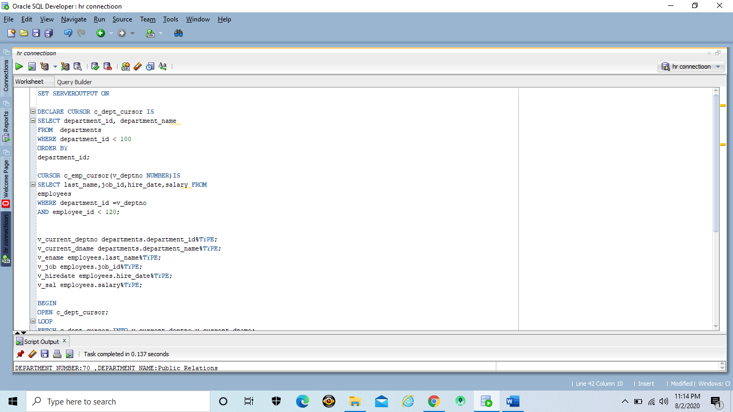

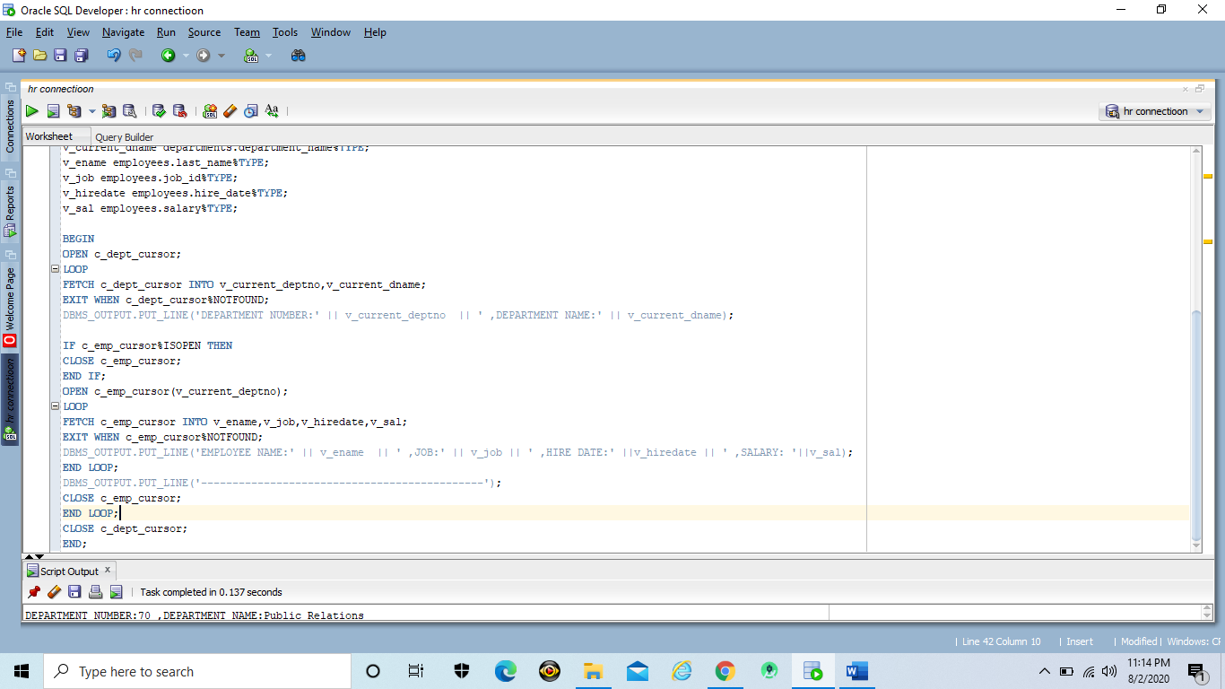

Output

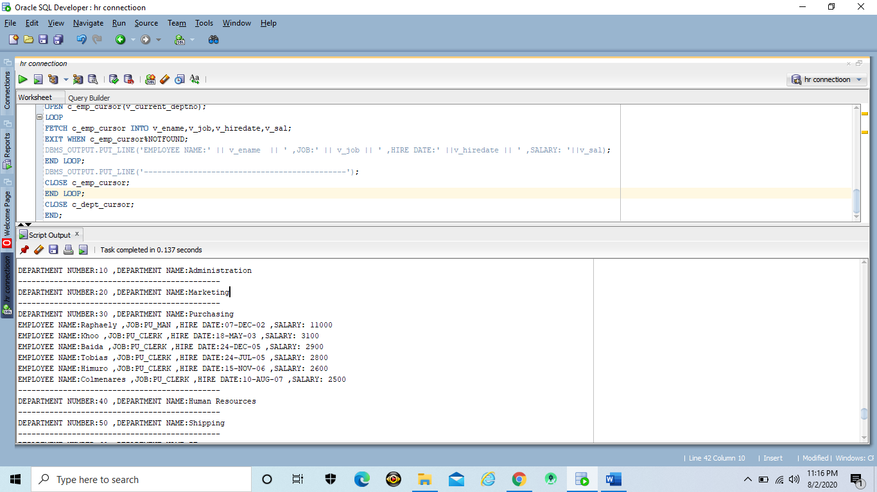

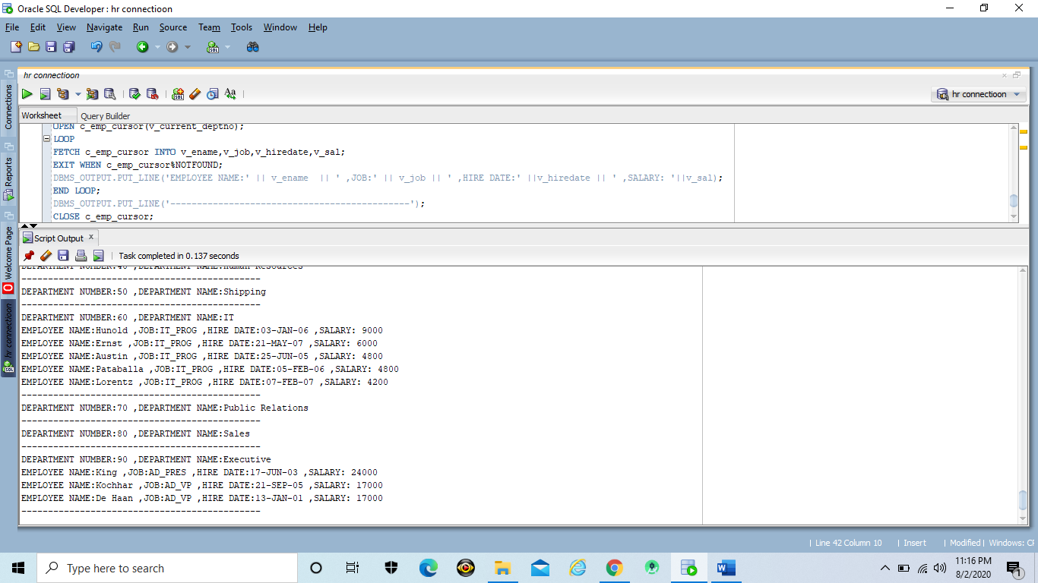

**Exercise 13 (1.2%)**

Declare a cursor dept_cursor to retrieve department_id and department_name for those departments with department_id less than 100. Order by department_id. Open dept_cursor and use a simple loop to fetch values into the variables declared. Display the department number and department name. Use the appropriate cursor attribute to exit the loop.

SET SERVEROUTPUT ON

DECLARE CURSOR c_dept_cursor IS

SELECT department_id, department_name

FROM departments

WHERE department_id < 100

ORDER BY

department_id;

v_current_deptno departments.department_id%TYPE;

v_current_dname departments.department_name%TYPE;

BEGIN

OPEN c_dept_cursor;

LOOP

FETCH c_dept_cursor INTO v_current_deptno,v_current_dname;

EXIT WHEN c_dept_cursor%NOTFOUND;

DBMS_OUTPUT.PUT_LINE('DEPARTMENT NUMBER: ' || v_current_deptno || ' DEPARTMENT NAME: ' || v_current_dname);

END LOOP;

CLOSE c_dept_cursor;

END;

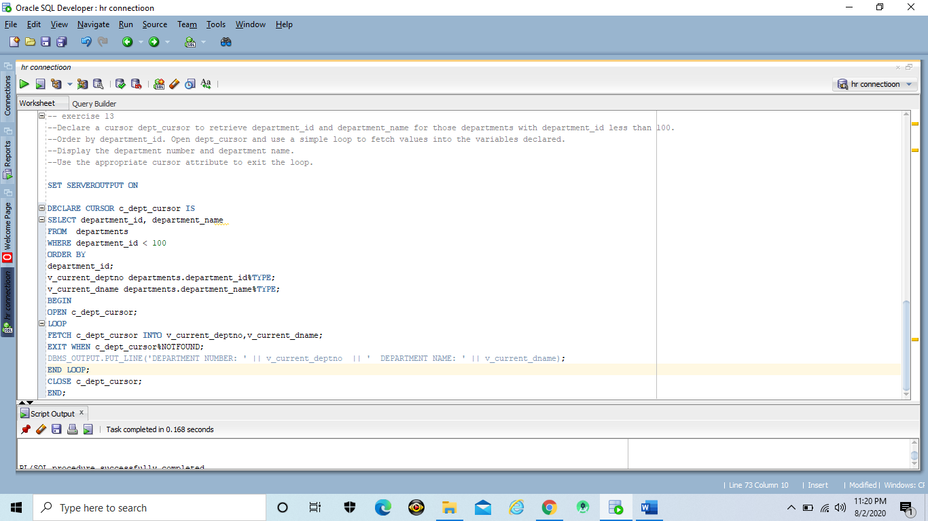

Output

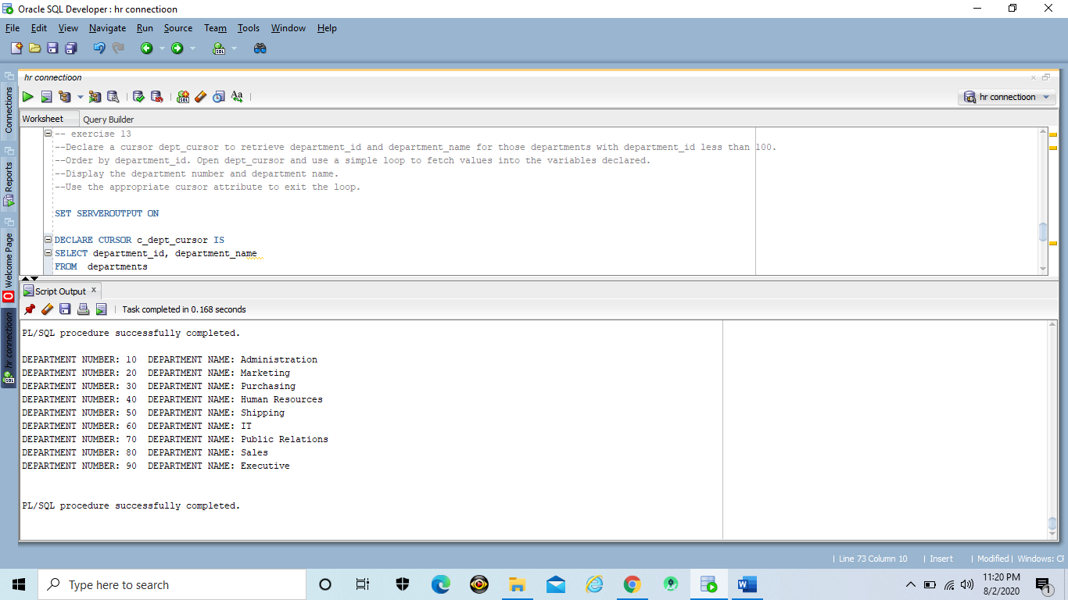

**Exercise 14 (1.2%)**

write a PL/SQL block that declares an exception for the Oracle Server error ORA-02292(integrity constraint violated – child record found). The block tests for the exception and outputs the error message.

In the executable section, display “You are not allowed to delete department number 60.” Include a DELETE statement to delete the department with department_id 60.

SET SERVEROUTPUT ON

DECLARE e_childrecord_exists EXCEPTION;

PRAGMA EXCEPTION_INIT(e_childrecord_exists,-02292);

BEGIN

DBMS_OUTPUT.PUT_LINE('DEPARTMENT is deleted whose id is 60');

DELETE FROM departments WHERE department_id=60;

EXCEPTION

WHEN e_childrecord_exists THEN

DBMS_OUTPUT.PUT_LINE('You are not allowed to delete department number 60.');

END;

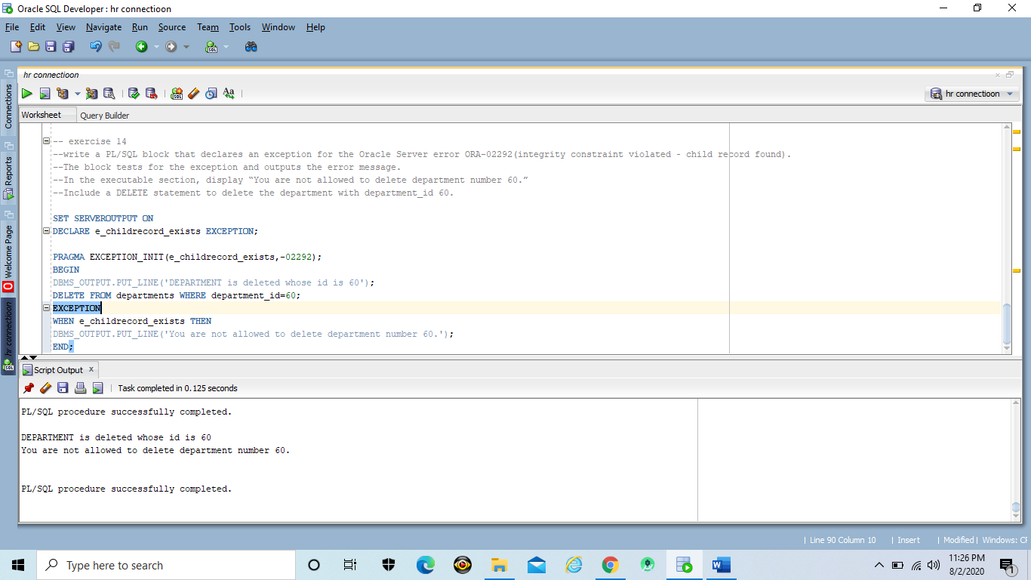

Output

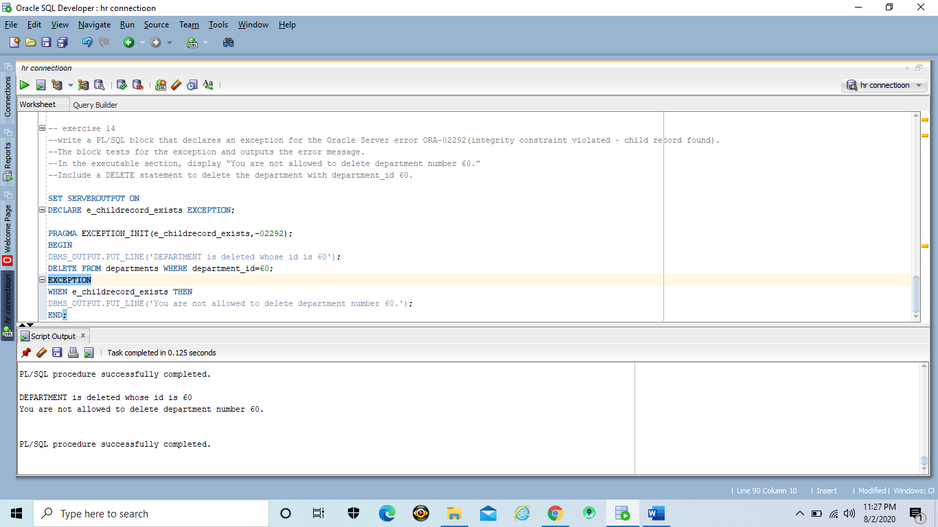

**Exercise 15 (1.2%)**

Give 4 oracle pre-defined errors

CASE_NOT_FOUND

NO_DATA_FOUND

TOO_MANY_ROWS

ZERO_DIVIDE

DUP_VAL_ON_INDEX

CURSOR_ALREADY_OPEN

INVALID_CURSOR

COLLECTION_IS_NULL

ROWTYPE_MISMATCH